GS 100524-123
dated 10.05.2024

Viktoriia Kopanieva

ВІДКРИТИЙ ВМІСТ: ВІД ФЕНОМЕНУ ДО ПАРАДИГМИ

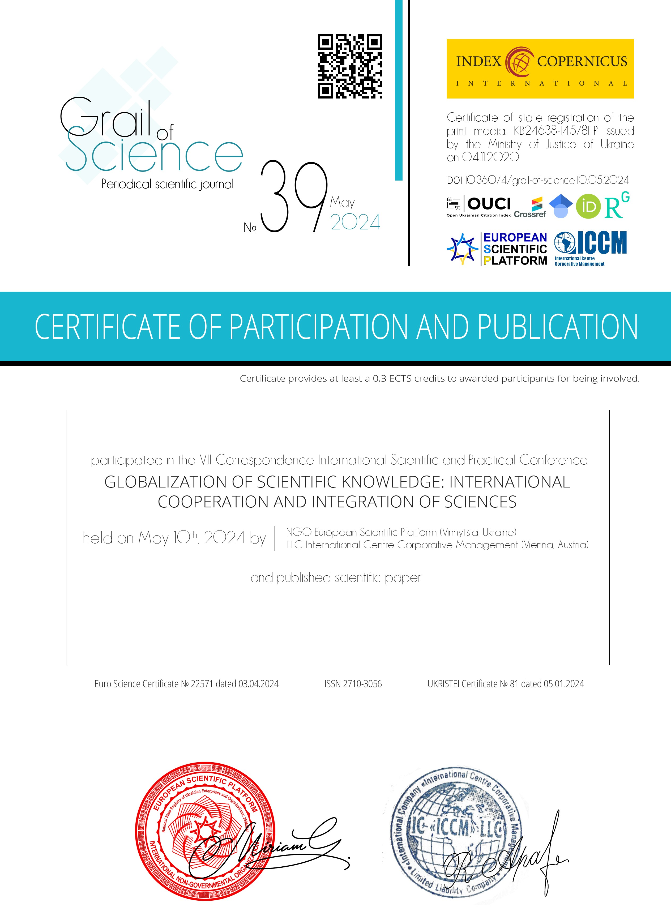
Head of the European Scientific Platform Chairman of the Organizing committee GOLDENBLAT MIRIAM
Head of Community Outreach
LLC «International Centre Corporative Management»
RACHAEL APARO

