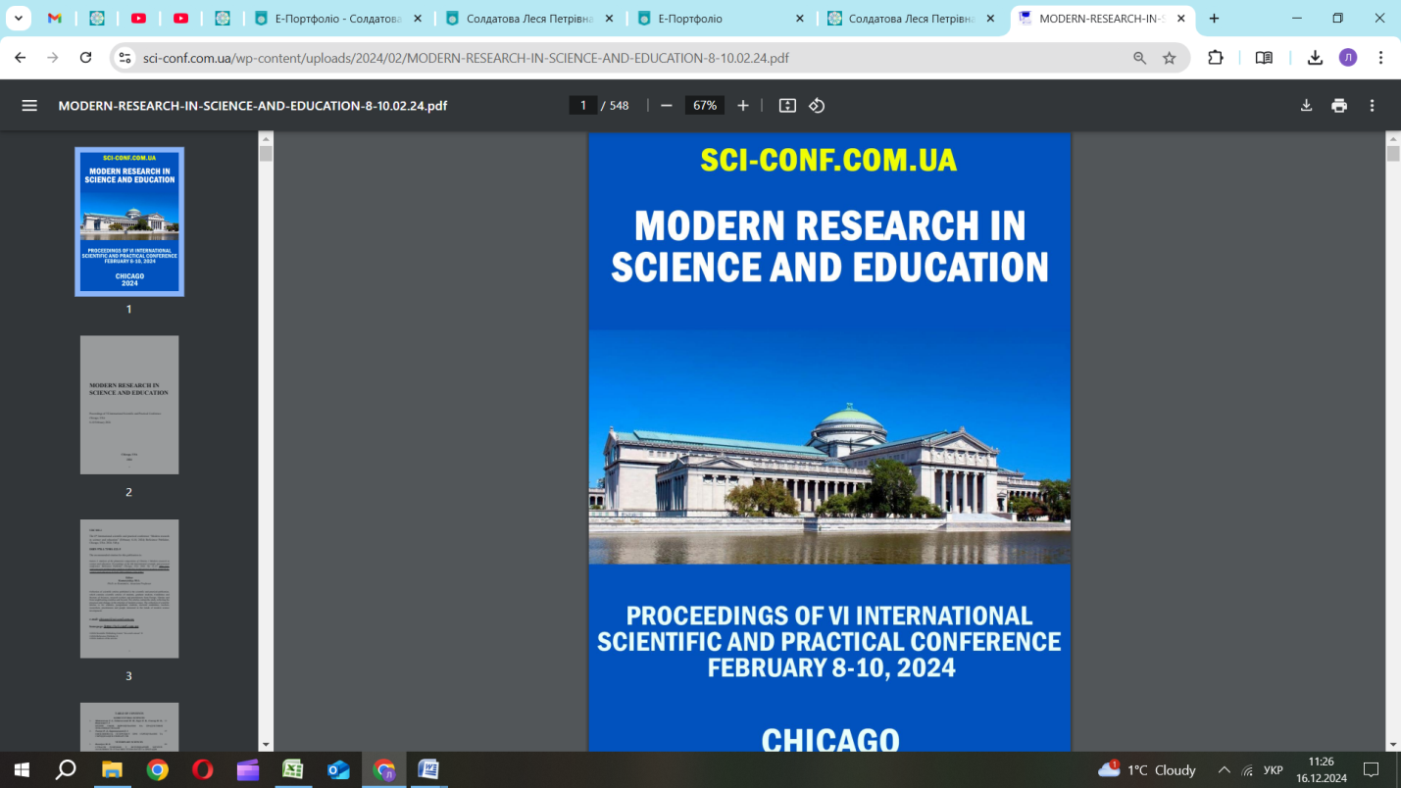

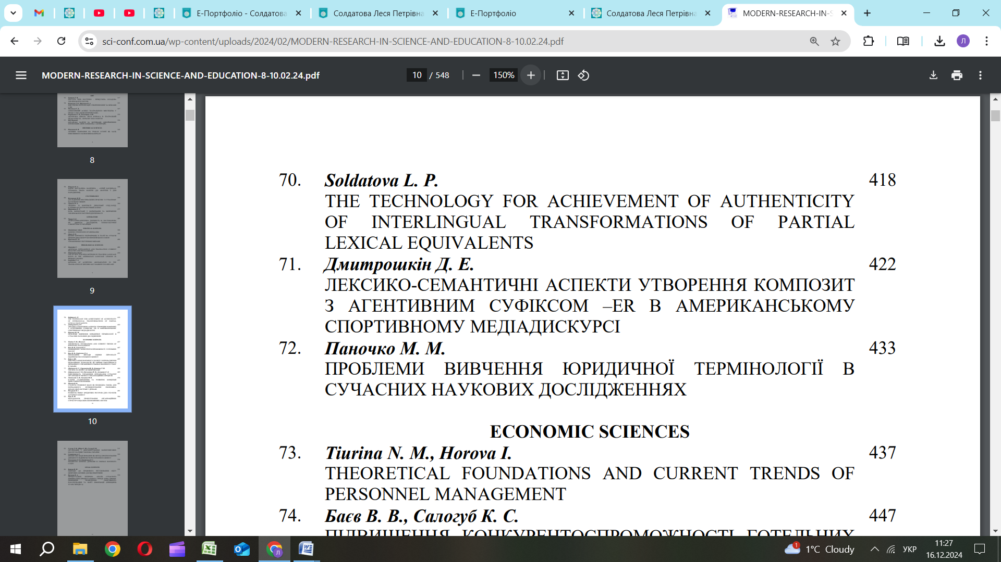

UDC 81`25 THE TECHNOLOGY FOR ACHIEVEMENT OF AUTHENTICITY OF INTERLINGUAL TRANSFORMATIONS OF PARTIAL LEXICAL EQUIVALENTS Soldatova Lesia Petrivna Candidate of Philological Sciences, Associate Professor, Associate Professor of the Department of English and Communication Borys Grinchenko Kyiv Metropolitan University Kyiv, Ukraine Abstract. The paper presents a technology for increasing the effectiveness of interlingual transformations on the example of partial lexical equivalents of acoustico-graphic codes (words). The basis of this technology is the creation of the explanatory formula of partial lexical equivalents of acoustico-graphic codes' meanings and the use of vector information correspondence to avoid and prevent communication errors. Key words: partial lexical equivalent, acoustico-graphic code, interlingual transformation, Introduction. This paper presents the author's effective technology for implementing interlingual transformations of information. It can be used in the theory and practice of translation and the process of teaching and learning “Languages of secondary socialization”. This technology makes it possible to eliminate or minimize conflicts in the “pictures of the world” of communicants in discourse (“the process of formation of information by human consciousness, determined by the necessity of the life activity of a person and society”) [1, p. 43]. The paper aims to create and show the technology that allows the forming of cross-cultural lexical skills of authentic “switching” from the “Language of Primary 419 Socialization” to the “Language of Secondary Socialization” and vice versa. The object of the paper is partial lexical equivalents in the process of interlingual transformations of information, learning, and teaching. The presentation of the main material. A partial lexical equivalent (PLE) is an acoustico-graphic code (AGC) (word) (“a single distinct conceptual unit of communication” [2, p 429]) that has informational crossing according to the essence in different languages, but the number of “secondary” meanings is different and doesn`t have complete informational crossing in different languages: дім (Ukrainian) (3 meanings) – house (8 meanings) (English), світ (Ukrainian) (10 meanings) – light (22 meanings) (English) etc. PLEs of AGCs exist in all languages as the result of brain physiology, national and cultural specifics of countries, national language code systems, penetration of one language to another, etc. PLEs of AGCs can be successfully used in the process of interlingual transformations of information with the achievement of complete authenticity. The task is to avoid direct coding and “word-to-word translation” of such AGCs from one language to AGCs of another language and to provide the correlation of information just only by a random coincidence of informational elements in languages. The technology consists of the explanatory formula PLE of AGC’s meaning (EFWM) creation. It consists of 3 operations: 1) Analytical description of the essence of the analyzed AGCs: • AGC «Нога» in Ukrainian (the “Language of Primary Socialization”): Нога–1. One of the two lower limbs of a person is used for standing or walking. Нога–2. One of the limbs of some animals and birds is used for standing or walking. 420 Нога–3. A piece of furniture, structures, mechanisms, etc. stands [3, p. 437]. • AGC “Leg” in English (“Language of Secondary Socialization”): Leg–1. One of the parts of the body of a human that is used for standing or walking. Leg–2. One of the parts of an animal body that is used for standing or walking, Leg–3. One of the thin vertical parts that support an object. Leg–4. A particular stage of a journey, competition, or activity. Leg–5. Either one of the two sides that form the angle of 90° in a right triangle. Leg–6. A piece of furniture stands. Leg–7. The part of a piece of clothing that you put your leg in [4]. 2) Finding the vector of informational accordance (VIA) (↔) [5] by studying the correlation of information content in every AGC meaning with the analogous lexical arrays in the analyzed languages. Based on the results of the correlation of the analyzed information arrays, we can identify VIAs that characterize the degree of authenticity and communicative equivalence of information. • Group of AGCs with the presence of informational crossing by essence (Ո): Нога–1 Ո Leg–1; Нога–2 Ո Leg–2; Нога–3 Ո Leg–6. • Group of AGCs with the lack of informational crossing by essence (Ո): Leg–3 Ո Нога–1 Ո Нога–2 Ո Нога–3; Leg–4 Ո Нога–1 Ո Нога–2 Ո Нога–3. Leg–5 Ո Нога–1 Ո Нога–2 Ո Нога–3. Leg–7 Ո Нога–1 Ո Нога–2 Ո Нога–3. 3) The results of differentiation for authentic interlingual transformations (↔) of Partial lexical equivalents of AGC: Leg–1 (English) ↔ нога (від стегна до ступні) (Ukrainian); Leg–2 (English) ↔ нога (лапа тварини) (Ukrainian); 421 Leg–3 (English) ↔ підпірка (Ukrainian); Leg–4 (English) ↔ тур (Ukrainian); Leg–5 (English) ↔ сторона (трикутника); Leg–6 (English) ↔ нога (опора меблів) (Ukrainian); Leg–7 (English) ↔ штанина (Ukrainian). Conclusion. The proposed technology can be successfully used the theory and practice of interlingual translations for carrying out interlingual transformations of information to achieve authenticity of intercultural communication, in teaching and learning “Language of Secondary Socialization”, and it can also be effectively used to involve and maintain the interest of students in the process of active and conscious learning of foreign languages. The technology can be successfully used together with the project method to develop students' creative abilities in the process of classroom, online, and distance teaching and learning. LIST OF REFERENCES: 1. Солдатова Л.П. Відносини: дискурс – інформація // “STUDIA LINGUISTICA” Зб.наук.праць. Випуск 5. Ч.2. – Вид-во Київського університету імені Тараса Шевченка, 2011. – 442-447 (543 с.). 2. Soldatova Lesia. One of the most effective methods of student`s word stock enrichment// ICT for Language Learning. // ICT for Language Learning. Conference Proceedings. Edited by Pixel. 6th Conference Edition – University Press. – Florence (Italy), 2013. – 429-434 (527 p.). 3. Словник української мови: в 11 томах. – Том 5, 1974. https://sum.in.ua/s/nogha. 4. https://dictionary.cambridge.org/dictionary/english/leg. 5. Soldatova Lesia. Teaching students of discourse creation peculiarities in a foreign language. // ICT for Language Learning. // ICT for Language Learning. Conference Proceedings. Edited by Pixel. 7th Conference Edition – University Press. – Florence (Italy), 2014. – 345-349 (574 p.)