GS 290422-032
dated 29.04.2022

Оksana Halchuk

ІНТЕРТЕКСТУАЛЬНІ НАРАТИВИ «ПАМПУШКИ» ГІ ДЕ МОПАССАНА

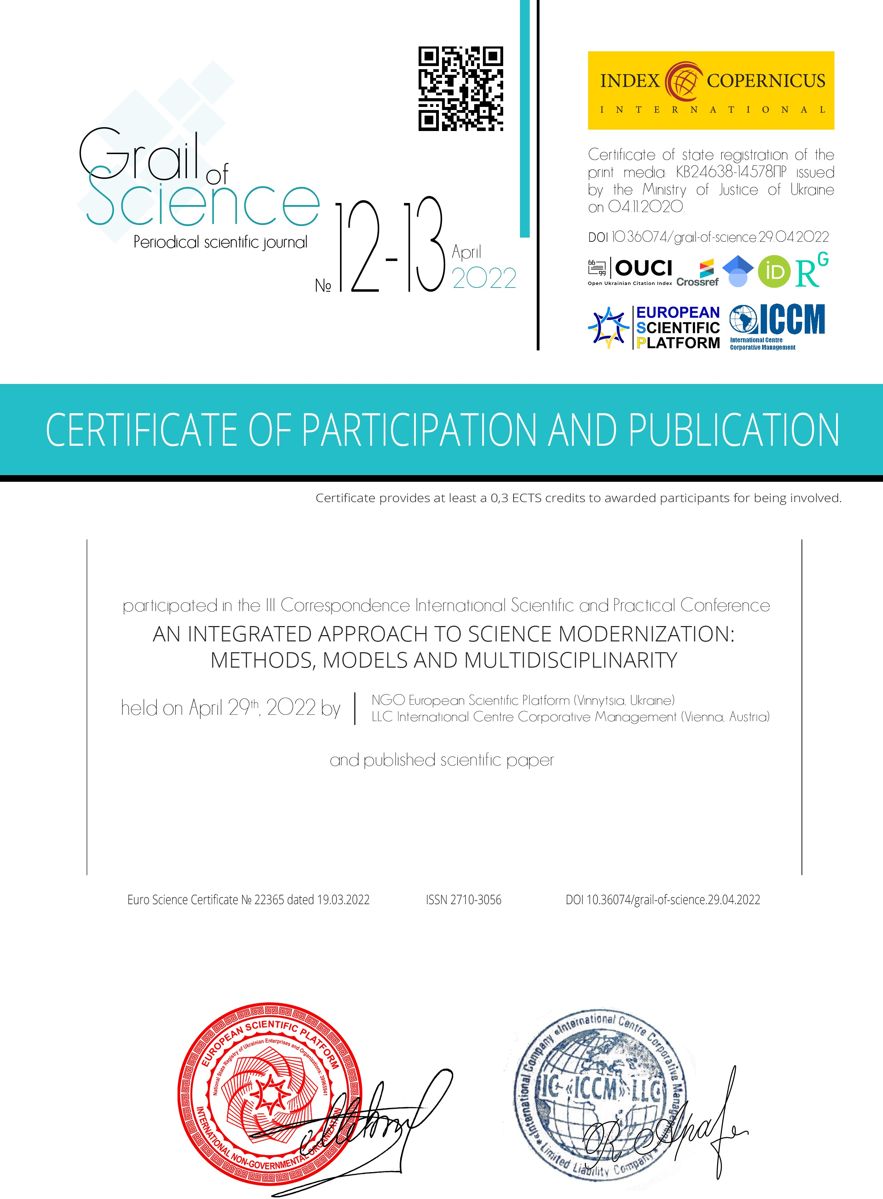
Head of the European Scientific Platform Chairman of the Organizing committee HOLDENBLAT MARIIA

Head of Community Outreach
LLC «International Centre Corporative Management»
RACHAEL APARO

